Reading Review #6

COMM 20 - Ishak

This assignment will take the place of Reading Review #6. It’s due February 20 at 7:30 am on Camino.

Instructions
- Watch the video “Science vs. Dave” at this link: vimeo.com/andrewishak/atoms
- Answer the questions below about reasoning, sources, and persuasion.

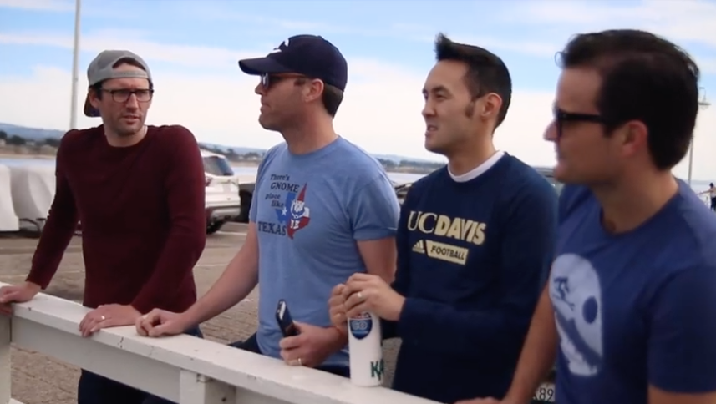
Aaron, Blake, Chad, and Zack

Questions
- What is one flaw in Aaron’s initial reasoning of why atoms don’t exist?
- Why do you think Blake and Chad seem so quickly persuaded by Aaron? Put another way: in what ways is Aaron more persuasive than Zack, even if Aaron’s arguments are specious?
- Aaron cites two websites in his argument for why atoms don’t exist. Using the information in your book on the quality of internet sources, how would you analyze these sites based on what you know about them?
- Chad makes one statement that is factually incorrect towards the end of the video (though no one questions its validity). What is it, and why is it incorrect?
- If you were Zack, what would you do differently to persuade Blake and Chad?

